Online Consumable Hemp Tax Monthly Tax Reporting Instructions
Payments submitted online must be received on or before the last day of the month following the month of sales of consumable hemp products made to customers. If consumable hemp products are not sold during any month, a submission of $0 total gross sales must be submitted.
PLEASE READ AND FOLLOW ALL INSTRUCTIONS CAREFULLY
** ACCEPTED FORMS OF PAYMENT **
Visa, Master Card, American Express, Discover or Electronic Check
Logging In
- Log on to access your account.
- You will need to enter your owner I.D. number associated with your AL ABC Board license(s) in order to complete the submission of your Consumable Hemp Tax due.
Your owner id number can be found on your printed license received from ABC Board License & Compliance Division. Please refer to the red box in the sample below to locate your owner id number. Note: the red box will not be shown on the license. 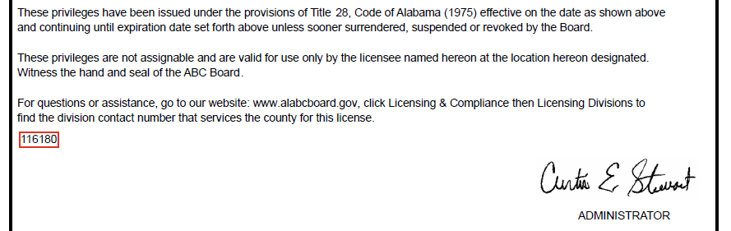

- Enter your complete ABC license number (If you have multiple licenses, choose one). The complete ABC license number is the type (“700”) followed by a dash (-) and the 9 digits shown as license number. (Example: 700-000123456.)
Hemp License Information
- Once logged in, select in the drop-down menu the correct location of the license to which you will be submitting the month’s consumable hemp tax.
- Review information to verify that all consumable hemp license types associated with your owner ID are displayed. Also, verify your Consumable Hemp Retailer Name and Consumable Hemp Retailer Address are correct.
- If any information is incorrect or you have questions, contact the ABC Tax & Trade Practices Division at (334) 260-5408.
County/Municipality Lookup
To ensure you are reporting to the correct county/municipality, you may click on the provided interactive hyperlink to perform a county/municipality look up. You will be required to enter the physical location address (street number, street address, city and zip code). If the city tax rate is not present on the interactive website, you are not located within that city’s limits for tax purposes.
Consumable Hemp Tax Reporting
Monthly Tax due for all license types associated with the same license location MUST be submitted at the same time. The following steps are provided to assist you:
- Select the correct county in the drop-down menu provided by the interactive hyperlink where your license is located.
- Select the correct municipality in the drop-down menu provided by the interactive hyperlink where you license is located. If the city tax rate was not present on the interactive website, please select “Outside City Limits” in the drop-down menu.
- Enter the name of a contact person, their email address and phone number (should we have any questions about this report). If that person has changed since your last submission, please check the box for new contact.
- Select the month in the drop-down menu for the reporting period.
- Enter the year for the reporting period. Filings can be no earlier than January 2026 and no later than the current month and year.
- Enter the total gross sales for each license type associated with the licensed location.
- Review generated Reported Gross Sales and Tax Amount Owed.
- You may submit reporting for additional months or vendor locations by clicking the “+Add” button.
- Review all the information on the summary page before continuing to the payment. If any information needs correction, edit buttons are available to return to prior pages.
Payment Types
- Select the payment type in the drop-down menu by selecting credit/debit card or electronic check.
- When paying by electronic check, an alternative payment date may be selected to schedule your tax payment for a future date, up to thirty days in advance. If the payment is not received from your banking institution by the last day of the month following the month of sale of consumable hemp products, your payment will be considered late.
- Before final submission, verify all information is correct. Changes to total gross sales and taxes owed can only be made by filing an amended paper return. (A copy of the paper return along with instructions is located on Alabama ABC Board website.)
Receipt Page
- After successful payment, a printable PDF copy of the receipt confirmation page with the information provided during the tax due submission will be available to download.
Receipt Email
- A payment confirmation email that includes Submission ID, transaction summary, transaction detail, and payment information will be sent to the email address provided.

